Name- D Sankirthana
Reg No- 711120106021
Link- https://wokwi.com/projects/364618433058770945

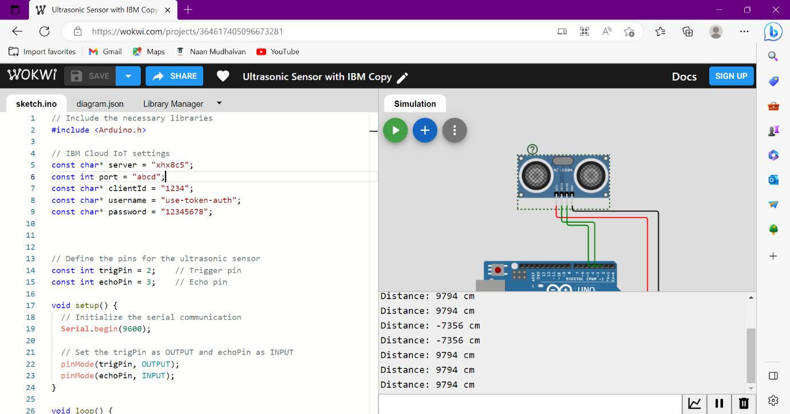
Code-
// Include the necessary libraries
#include <Arduino.h>

// IBM Cloud IoT settings
const char* server = "xhx8c5";
const int port = "abcd";
const char* clientId = "1234";
const char* username = "use-token-auth";
const char* password = "12345678";

// Define the pins for the ultrasonic sensor
const int trigPin = 2; // Trigger pin
const int echoPin = 3; // Echo pin

void setup() {
// Initialize the serial communication
Serial.begin(9600);

// Set the trigPin as OUTPUT and echoPin as INPUT
pinMode(trigPin, OUTPUT);
pinMode(echoPin, INPUT);
}

void loop() {
// Clear the trigPin
digitalWrite(trigPin, LOW);
delayMicroseconds(2);

// Send a trigger pulse
digitalWrite(trigPin, HIGH);
delayMicroseconds(10);
digitalWrite(trigPin, LOW);

// Measure the duration of the echo pulse
long duration = pulseIn(echoPin, HIGH);

// Calculate the distance
// Speed of sound = 343 m/s or 34300 cm/s
// Divide by 2 to account for the round trip of the sound wave
// Distance in cm = duration * 34300 / 2
int distance = duration * 34300 / 2;

// Print the distance to the serial monitor
Serial.print("Distance: ");
Serial.print(distance);
Serial.println(" cm");

delay(1000); // Wait for a second before taking the next measurement
}

